**Assignment 1 CSU33081 October 2020**

Please answer where asked by entering A to E as appropriate and upload this document along with your typewritten solutions (as a separate document) via Blackboard. Both documents should be in .pdf format.

Q1.

How would we represent the summation of the following two polynomials in MATLAB?

$$2x^{2}+2x-6$$

and $x^{3}+2x-4$

Choose your answer from the following:

1. [-6 2 2]+[-4 2 1]
2. [2 2 -6]+[1 2 4]
3. [2 2 2 -6]+[1 0 2 -4]
4. [2 2 -6]+[1 2 -4]
5. None of these

Answer: E

The right answer is [2 2 -6] + [1 0 2 -4]

Q2.

What is the final value of the matrix A when the following MATLAB commands are executed?

A=eye(3,3);

for x=1:2:3

A(1,x)=1;

End

Choose your answer from the following:

$\left(\begin{matrix}1 & 1 & 1 \\ 0 & 1 & 0 \\ 1 & 1 & 1\end{matrix}\right)$

$\left(\begin{matrix}1 & 0 & 1 \\ 0 & 1 & 0 \\ 0 & 0 & 1\end{matrix}\right)$

$\left(\begin{matrix}1 & 1 & 1 \\ 1 & 1 & 1 \\ 1 & 1 & 1\end{matrix}\right)$

$\left(\begin{matrix}0 & 0 & 1 \\ 0 & 0 & 0 \\ 0 & 0 & 0\end{matrix}\right)$

1. None of these

Answer: B

When I executed the above command in MATLAB, I got the value of B.

Q3.

What is the displayed result when the following MATLAB script file is executed?

x=[6:8;-1:1;567];

y=x(:,3);

size(y’)

Choose your answer from the following:

1. 1 1
2. 3 1
3. 1 3
4. 3 3
5. None if these

Answer: C

When I typed the above command, I got the value of C. 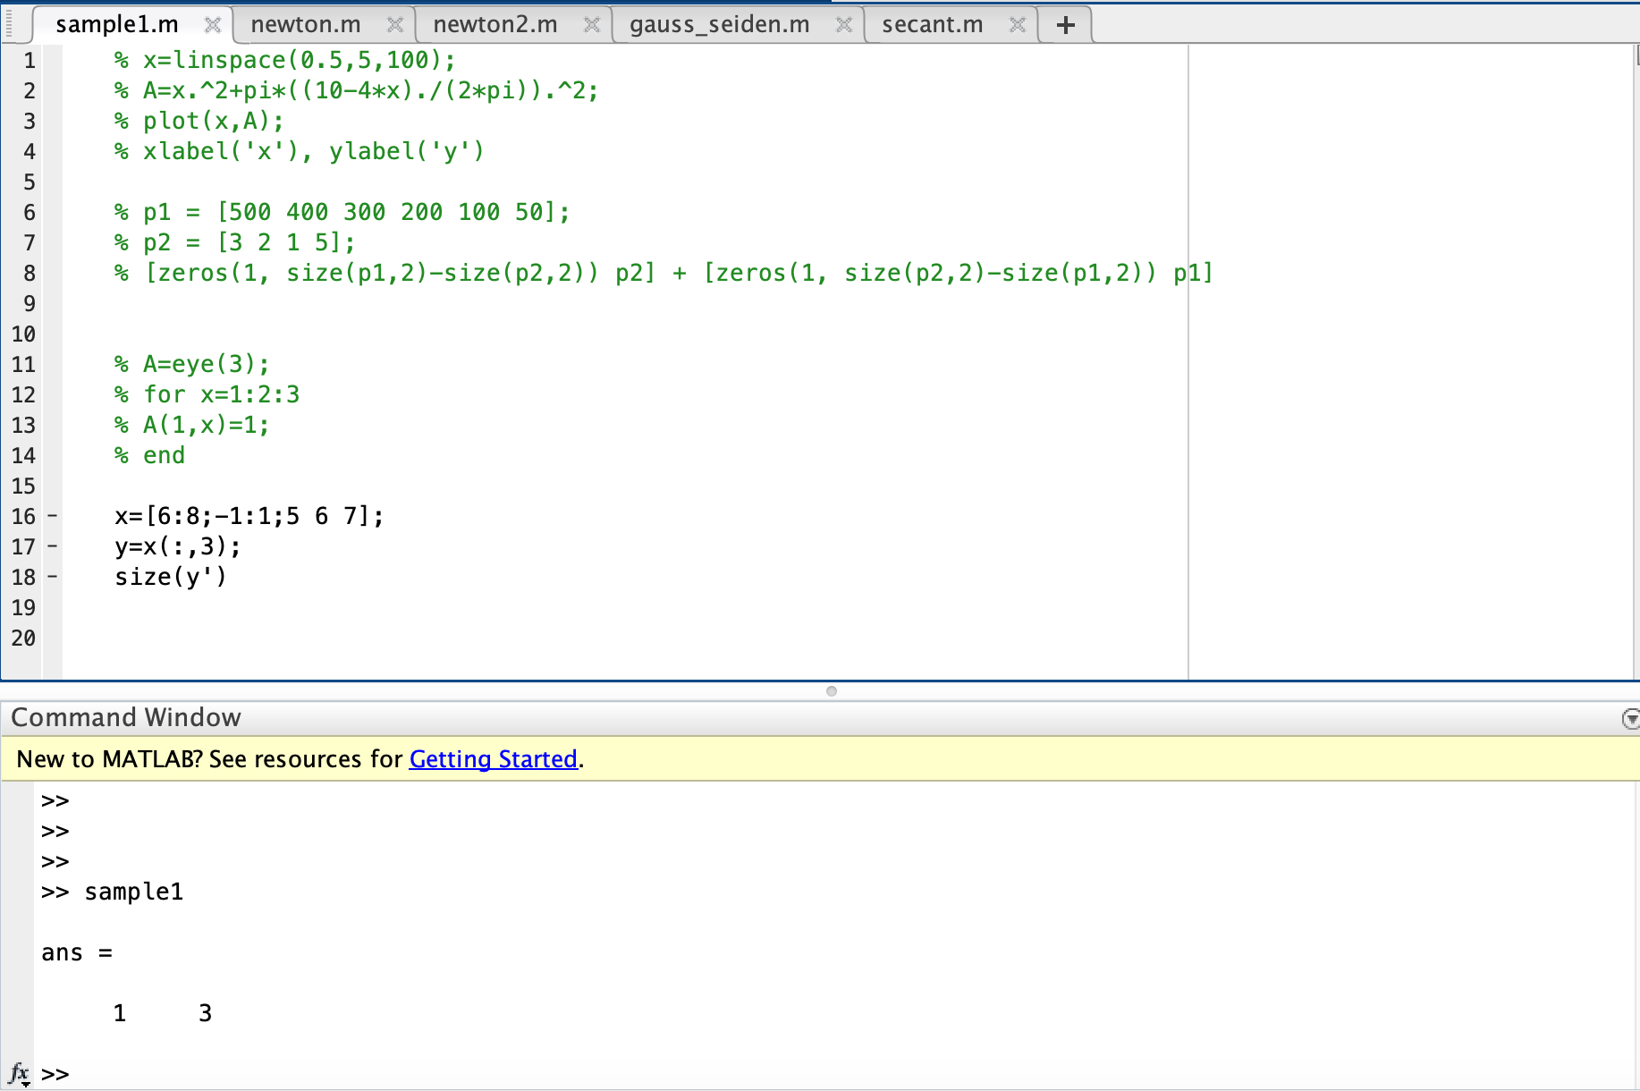

Q4.

Calculate the Truncation Error, $f\left(x\right)-P_{2}(x)$ at $x=2.5$, in approximating the function $f\left(x\right)=3-17x^{3}.$  
For the approximation use the Taylor Series polynomial approximation of degree two, $P_{2}(x)$, expanded about the point $x_{0}=2.0.$

Choose your answer from the following:

1. -7.182755
2. -7.645227
3. -4.358405
4. -7.994173
5. None of these

Answer: E

f(x) = 3-17x^3 = -17x^3 + 3

f’(x) = -51x^2

f’’(x) =-102x

At X0 = 2.0

P2(x) = f(x0) + f’(x0)/1! (x-x0) + f’’(x0)/2!(x-x0)^2

f(2.0) = 3 – 17(2.0)^3 = -133

f’(2.0) = -51 (2.0)^2 = -204

f’’(2.0) = -102(2.0) = -204

Thus,

P2(x) = f(x0) + f’(2.0)/1! (x-2.0) + f’’(2.0)/2!(x-2.0)^2

= -133 +(-204)/1! (x-2.0) +(-204)/2!(x-2.0)^2

= -133 – 204x + 408 – 102x^2 + 408x – 408

= -102x^2 + 204x -133

f(2.5) = 3 -17(2.5)^3 = -262.625

P2(2.5) = -102(2.5)^2 + 204(2.5) -133 = -260.5

Therefore,

Truncation error = f(2.5) - P2(2.5) = -260.5 – (-262.625) = 2.125

Q5.

Use the Secant Method to find a root of the function

$$f\left(x\right)=16x^{5}-73x^{2}-133$$

accurate to within an error of $ϵ=x_{n}-x_{n-1}=0.001$, where $x_{n}$ is the value of $x$ at the $n^{th}$ iteration. Use starting points $x_{0}=3$ and $x_{1}=2.5$

Choose your answer from the following:

1. 0.982274
2. 0.342803
3. 1.900475
4. 1.513896
5. None of these

Answer: C

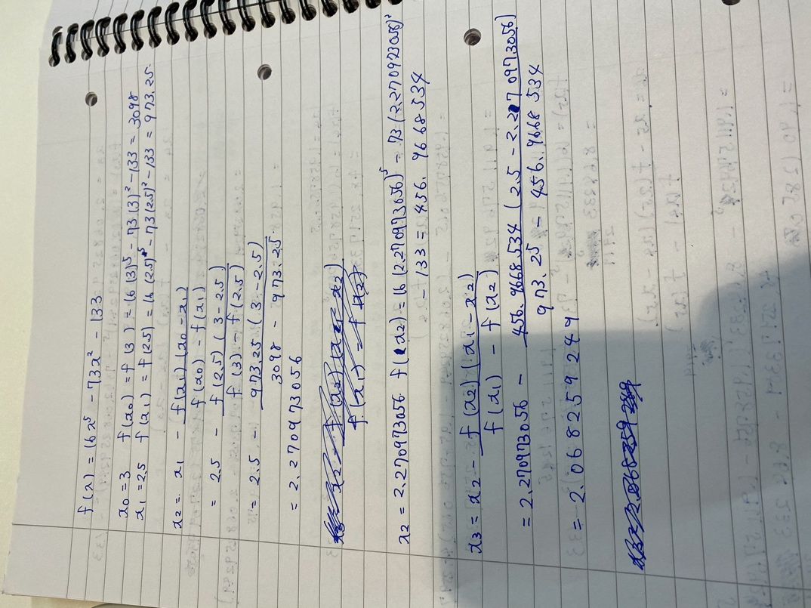

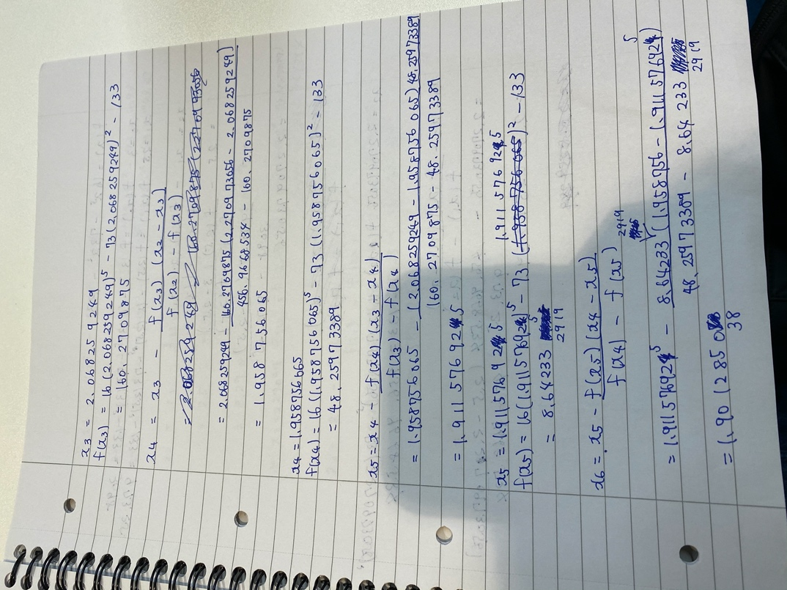

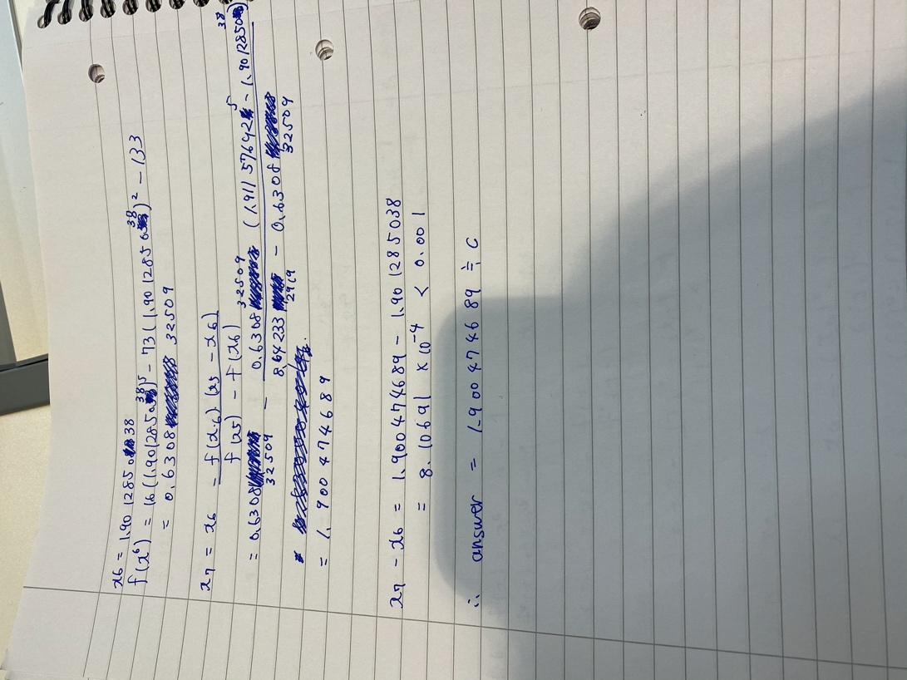

Q6.

Use Newton-Raphson’s Method to find a root of the equation:

$f\left(x\right)=x^{6}-x-1$ accurate to within an error of $ϵ=x_{n}-x_{n-1}=0.001$, where $x_{n}$ is the value of $x$ at the $n^{th}$ iteration. Use a starting point of $x_{0}=1.5.$

Choose your answer from the following:

1. 1.134778
2. 0.616384
3. 1.505056
4. 1.160489
5. None of these

Answer: A

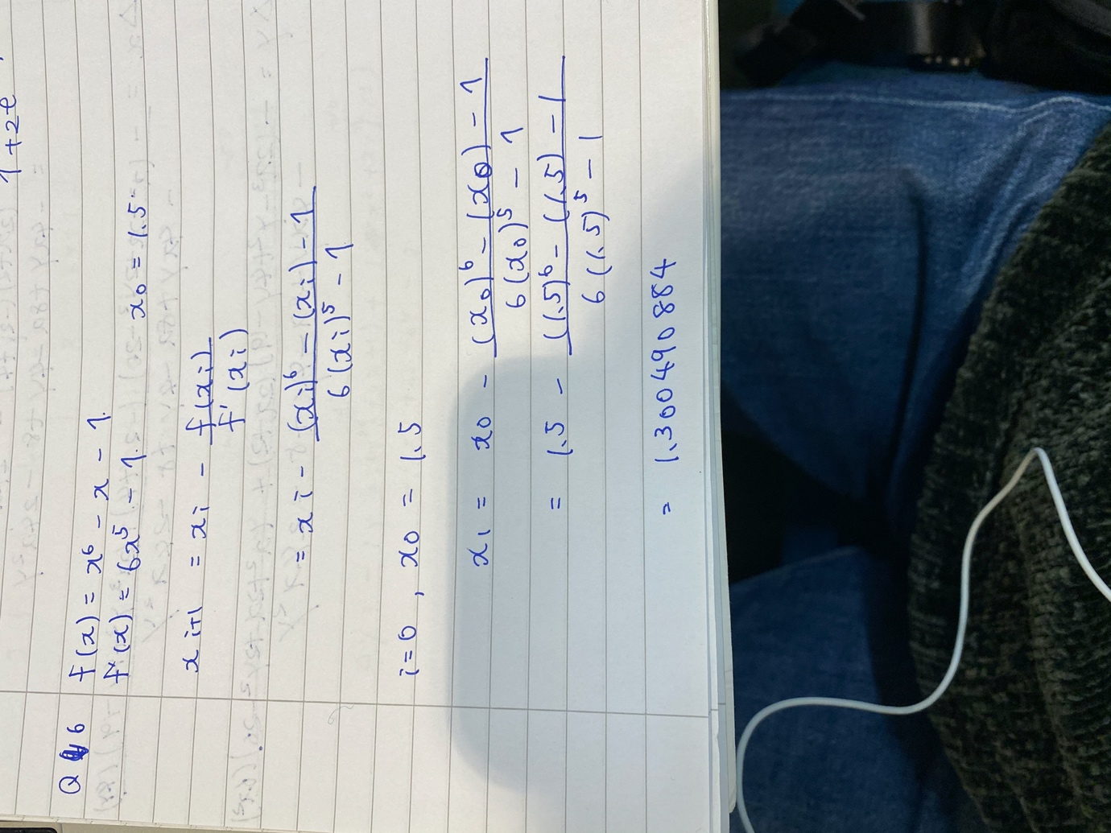

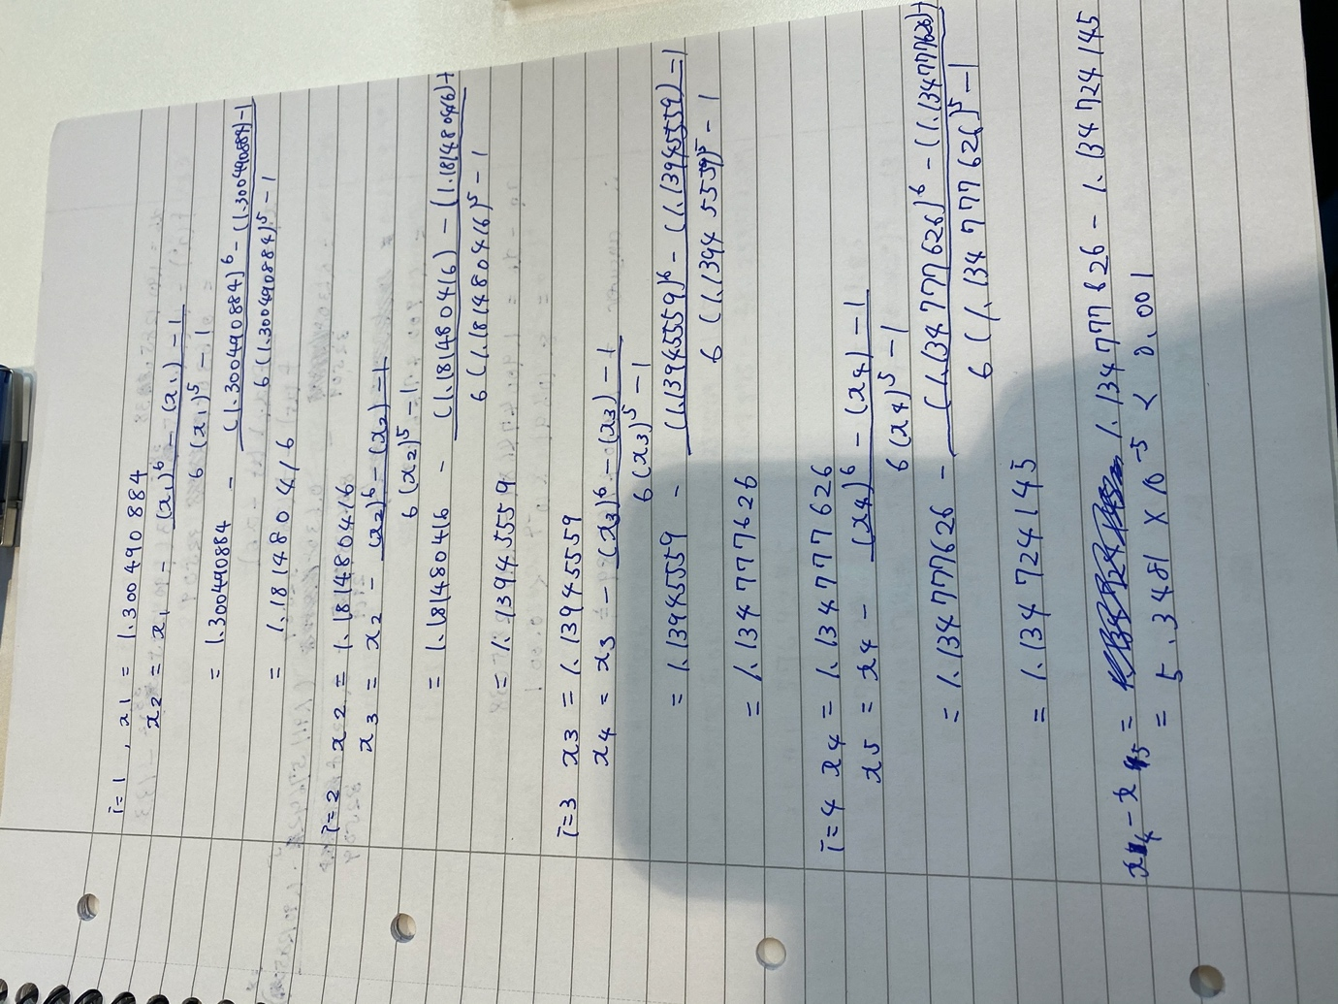

Q7.

Use Newton’s Method to solve the following equations for $x$ and $y$. Perform three iterations.

$$x^{2}+xy=10$$

$$y+3xy^{2}=57$$

You should use an initial guess of $x=1.5$ and $y=3.5$. Perform three iterations.

Choose your answer from the following:

$x=3, y=3$

$x=2, y=3$

$x=2, y=2$

$x=3, y=2$

1. None of these

Answer: E

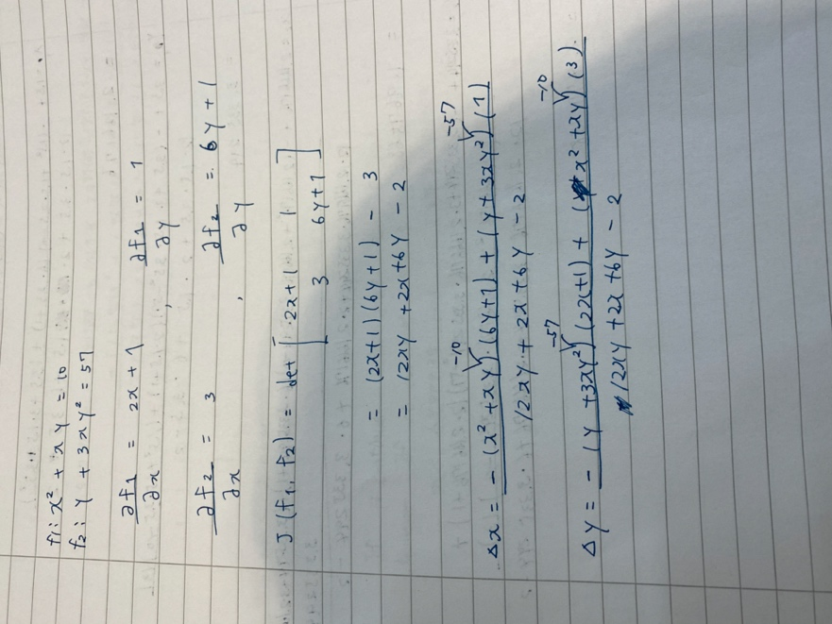

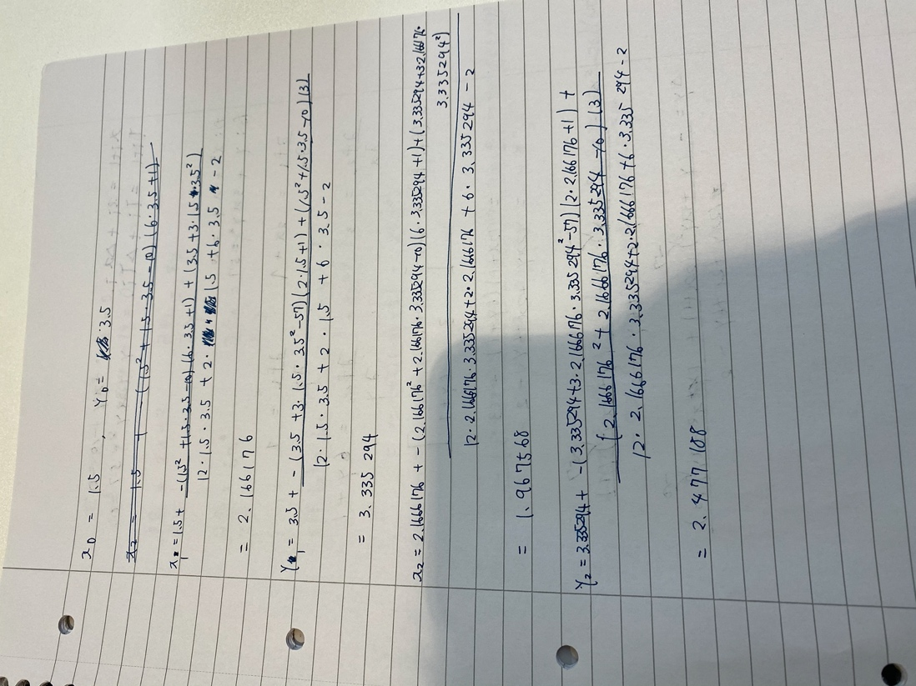

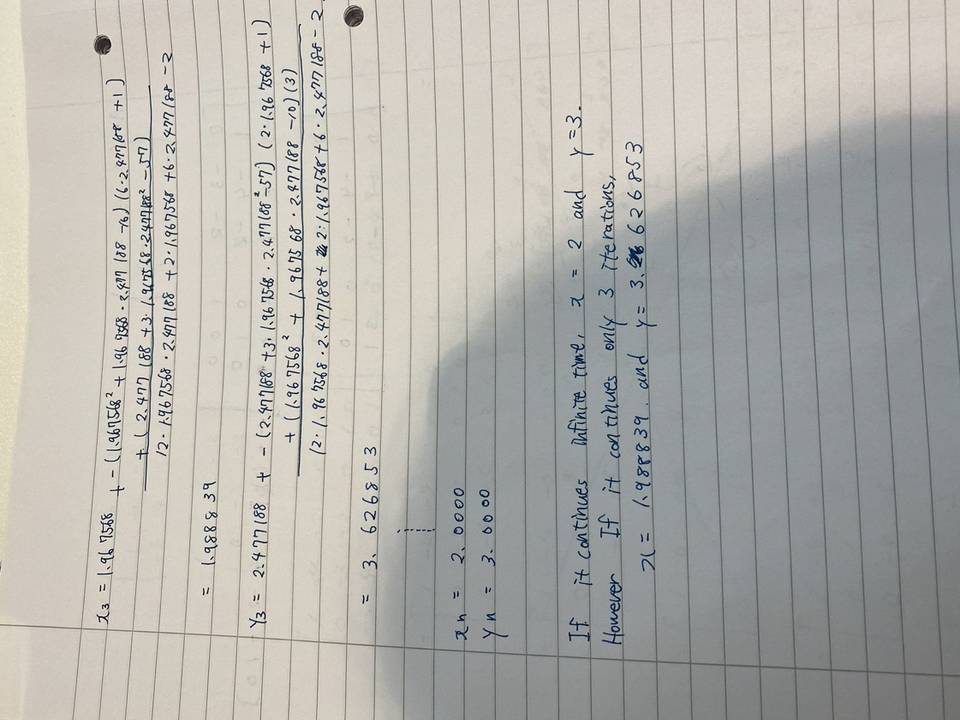

Q8.

Find the inverse of the following matrix using the Gauss-Jordan Method:

$$A=\left(\begin{matrix}0 & -3 & -2 \\ 1 & -4 & -2 \\ -3 & 4 & 1\end{matrix}\right)$$

Choose your answer form the following:

$\left(\begin{matrix}-4 & 5 & 2 \\ 5 & -6 & 2 \\ 8 & 9 & -3\end{matrix}\right)$

$\left(\begin{matrix}-4 & 5 & 2 \\ -5 & 6 & 2 \\ -8 & -9 & 3\end{matrix}\right)$

$\left(\begin{matrix}-4 & -5 & 2 \\ 5 & -6 & 2 \\ -8 & 9 & 3\end{matrix}\right)$

$\left(\begin{matrix}4 & -5 & -2 \\ 5 & -6 & -2 \\ -8 & 9 & 3\end{matrix}\right)$

1. None of these

Answer: D

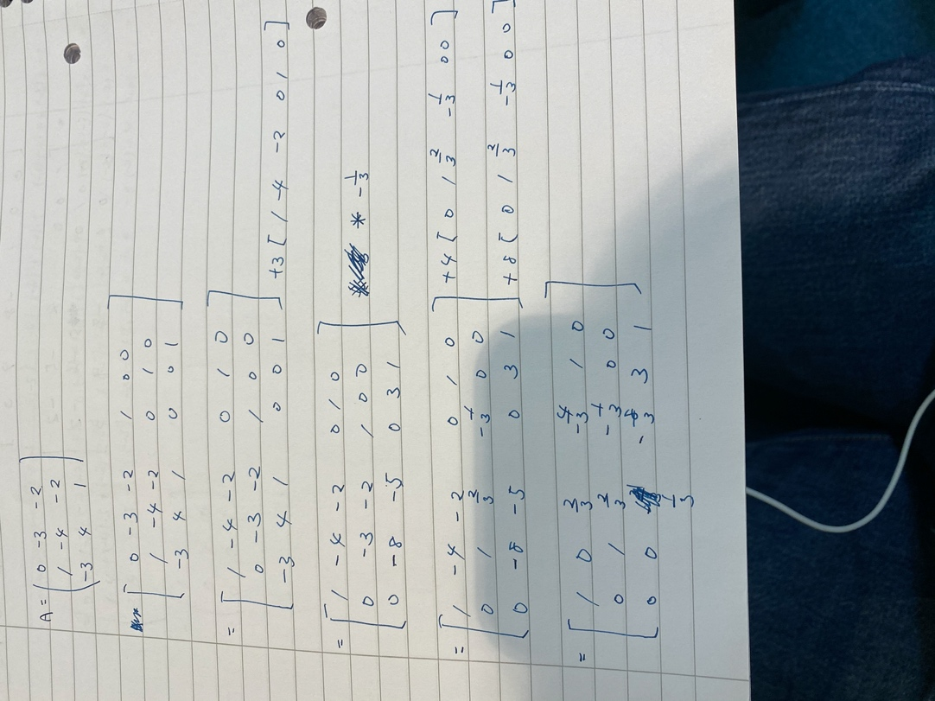

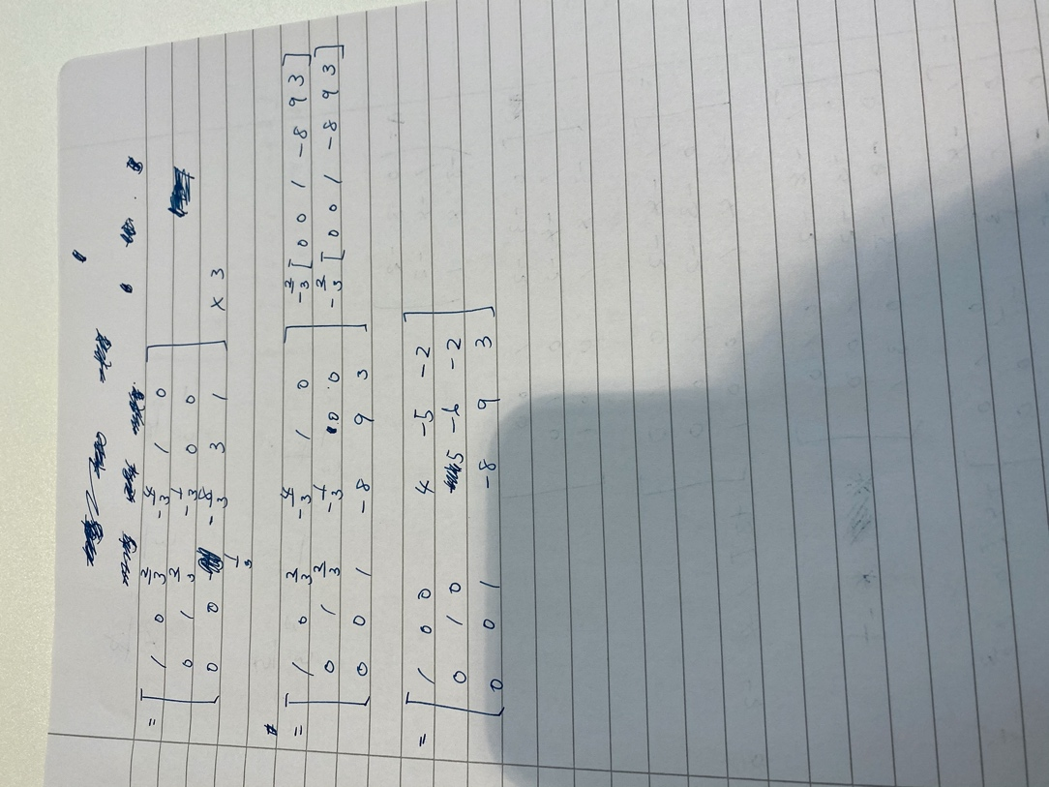

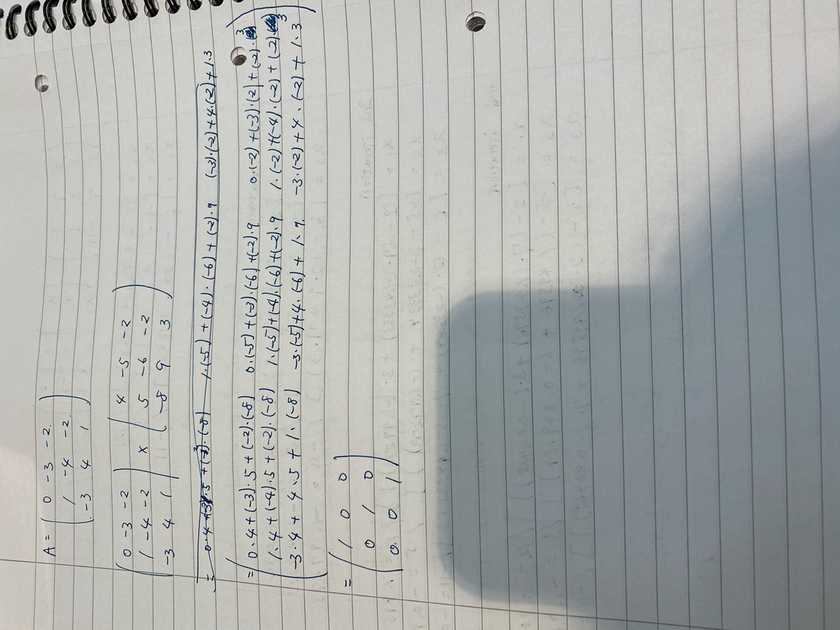

Q9.

Using $x_{1}=1$, $x_{2}=3, x_{3}=5$ as an initial guess at the solution, determine the values of $x_{1}$, $x_{2}$ and $x_{3}$ that result from three iterations of the Gauss-Seidel method applied to this matrix equation:

$\left(\begin{matrix}12 & 7 & 3 \\ 1 & 5 & 1 \\ 2 & 7 & -11\end{matrix}\right)\left(\begin{matrix}x_{1} \\ x_{2} \\ x_{3}\end{matrix}\right)$ = $\left(\begin{matrix}2 \\ -5 \\ 6\end{matrix}\right)$

Choose your answer from the following:

1. $x_{1}=-2.833$, $x_{2}=-1.4333, x_{3}=-1.9727$
2. $x_{1}=1.4959$, $x_{2}=-0.90464, x_{3}=-0.84914$
3. $x_{1}=0.90666$, $x_{2}=-1.0115, x_{3}=-1.0243$
4. $x_{1}=1.2148$, $x_{2}=-0.72060, x_{3}=-0.82451$
5. None of these

Answer: C

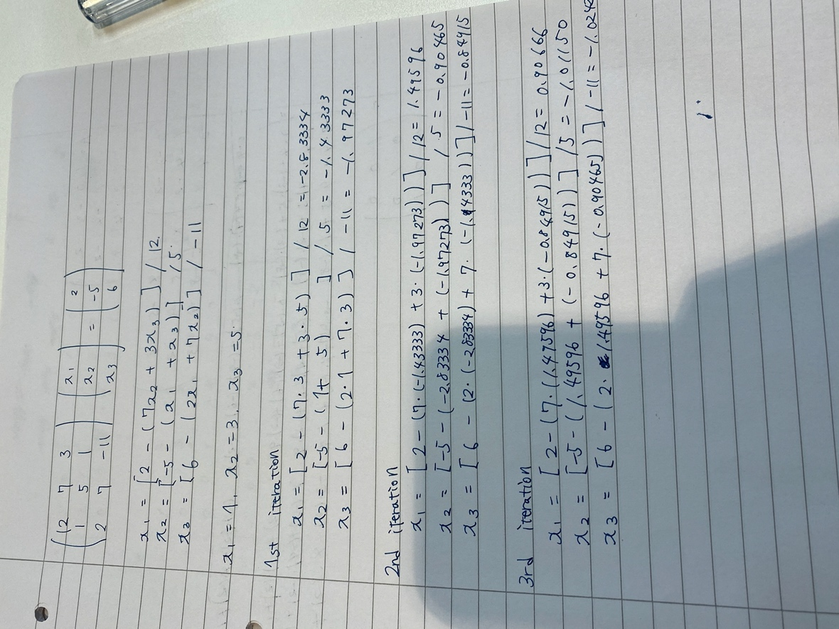

Q10.

Solve the following equation for $x=\left({\begin{aligned}x_{1} \\ x_{2}\end{aligned} \atop x_{3}}\right)$ using LU Decomposition:

$$\left(\begin{matrix}1 & 2 & 4 \\ 3 & 8 & 14 \\ 2 & 6 & 13\end{matrix}\right)\left(\begin{matrix}x_{1} \\ x_{2} \\ x_{3}\end{matrix}\right)=\left(\begin{matrix}3 \\ 13 \\ 4\end{matrix}\right)$$

Choose your answer from the following:

$x=\left(\begin{matrix}3 \\ 13 \\ 4\end{matrix}\right)$

$x=\left(\begin{matrix}3 \\ 4 \\ -2\end{matrix}\right)$

$x=\left(\begin{matrix}3 \\ 13 \\ -4\end{matrix}\right)$

$x=\left(\begin{matrix}3 \\ 4 \\ 2\end{matrix}\right)$

2. None of these

Answer: B

